WEB DEVELOPMENT USING WORDPRESS

Project On

One Page Website For A Restaurant



Submitted by

Kalluri Hema Srija (20ME1A0467)

Veduruparthi Teja (20ME1A04A5)

Abbindi Lokitha Sai (20ME1A0456)

Kodi Bhavani Raja (20ME1A0469)

DEPARTMENT OF ELECTRONICS AND COMMUNICATION ENGINEERING

RAMACHANDRA COLLEGE OF ENGINEERING ELURU

(Affiliated to JNTU,KAKINADA)

TABLE OF CONTENTS

1.ABSTRACT

2.OBJECTIVE

3.INTRODUCTION

4.METHODOLOGY

5.CODE

6.CONCLUSION

ABSTRACT:

The 1990s have witnessed the proliferation and hypergrowth of the Internet which,

combined with traditional IT technologies, is creating a global, and cost-effective platform for

businesses to communicate and conduct commerce. Because of today's shrinking world,

companies must create new sources of competitive advantage almost on a daily basis. This fact

becomes critical for small and medium enterprises (SMEs) because they are considered to be a

major component of all economies and are generally considered to be flexible, adaptive and

innovative organizations, which appears to make them a good fit for electronic (e)-commerce. The

present study presents an in-depth analysis of the e-commerce development stages and the

facilitators and barriers for SMEs during each stage

The 1990s have witnessed the proliferation and hypergrowth of the Internet which,

combined with traditional IT technologies, is creating a global, and cost-effective platform for

businesses to communicate and conduct commerce. Because of today's shrinking world,

companies must create new sources of competitive advantage almost on a daily basis. This fact

becomes critical for small and medium enterprises (SMEs) because they are considered to be a

major component of all economies and are generally considered to be flexible, adaptive and

innovative organizations, which appears to make them a good fit for electronic (e)-commerce. The

present study presents an in-depth analysis of the e-commerce development stages and the

facilitators and barriers for SMEs during each stage

The 1990s have witnessed the proliferation and hypergrowth of the Internet which,

combined with traditional IT technologies, is creating a global, and cost-effective platform for

businesses to communicate and conduct commerce. Because of today's shrinking world,

companies must create new sources of competitive advantage almost on a daily basis. This fact

becomes critical for small and medium enterprises (SMEs) because they are considered to be a

major component of all economies and are generally considered to be flexible, adaptive and

innovative organizations, which appears to make them a good fit for electronic (e)-commerce. The

present study presents an in-depth analysis of the e-commerce development stages and the

facilitators and barriers for SMEs during each stage

The 1990s have witnessed the proliferation and hypergrowth of the Internet which,

combined with traditional IT technologies, is creating a global, and cost-effective platform for

businesses to communicate and conduct commerce. Because of today's shrinking world,

companies must create new sources of competitive advantage almost on a daily basis. This fact

becomes critical for small and medium enterprises (SMEs) because they are considered to be a

major component of all economies and are generally considered to be flexible, adaptive and

innovative organizations, which appears to make them a good fit for electronic (e)-commerce. The

present study presents an in-depth analysis of the e-commerce development stages and the

facilitators and barriers for SMEs during each stage

The 1990s have witnessed the proliferation and hypergrowth of the Internet which,

combined with traditional IT technologies, is creating a global, and cost-effective platform for

businesses to communicate and conduct commerce. Because of today's shrinking world,

companies must create new sources of competitive advantage almost on a daily basis. This fact

becomes critical for small and medium enterprises (SMEs) because they are considered to be a

major component of all economies and are generally considered to be flexible, adaptive and

innovative organizations, which appears to make them a good fit for electronic (e)-commerce. The

present study presents an in-depth analysis of the e-commerce development stages and the

facilitators and barriers for SMEs during each stage

The 1990s have witnessed the proliferation and hypergrowth of the Internet which,

combined with traditional IT technologies, is creating a global, and cost-effective platform for

businesses to communicate and conduct commerce. Because of today's shrinking world,

companies must create new sources of competitive advantage almost on a daily basis. This fact

becomes critical for small and medium enterprises (SMEs) because they are considered to be a

major component of all economies and are generally considered to be flexible, adaptive and

innovative organizations, which appears to make them a good fit for electronic (e)-commerce. The

present study presents an in-depth analysis of the e-commerce development stages and the

facilitators and barriers for SMEs during each stage

Creating a one-page website for a restaurant involves several key steps:

1. *Install WordPress*: Begin by installing WordPress on your web hosting server if you haven't already.

2. *Choose a Theme*: Select a one-page WordPress theme that suits your restaurant's style and branding from the WordPress theme directory or third-party marketplaces.

3. *Customize the Theme*: Personalize the theme by uploading your restaurant's logo, setting the color scheme, and configuring other options to match your brand identity.

4. *Create Sections*: Divide your one-page website into sections such as About Us, Menu, Specials, and Contact Us.

5. *Add Content*: Populate each section with relevant content. For example, in the Menu section, include your restaurant's menu items with descriptions and prices.

6. *Set Up Navigation*: Configure the navigation menu to smoothly scroll to different sections of the page. Most one-page themes have built-in support for this.

7. *Optimize for Mobile*: Ensure your website looks and functions well on mobile devices by testing it on various screen sizes.

8. *Test and Launch*: Thoroughly test your website to check for any issues such as broken links or formatting errors before launching it to the public.

By following these steps, you can create an attractive and functional one-page website for your restaurant using WordPress.

OBJECTIVE:

The objective is to create a visually appealing and user-friendly one-page website for a restaurant using WordPress. This website should effectively showcase the restaurant's brand identity, menu offerings, specials, and contact information while providing a seamless user experience. Additionally, the website should be optimized for mobile devices and thoroughly tested to ensure functionality and usability across different screen sizes. Ultimately, the goal is to attract and engage customers, encouraging them to visit the restaurant or make reservations.

INTRODUCTION:

In today's digital age, having an online presence is essential for businesses, including restaurants. A well-designed website serves as a virtual storefront, enticing customers with tantalizing images, informative content, and easy-to-use navigation. For restaurants, a one-page website can be particularly effective, providing a concise yet comprehensive overview of the establishment's offerings.

In this project, our objective is to create a dynamic one-page website for a restaurant using WordPress. This website will serve as a digital hub where customers can learn about the restaurant, explore its menu, discover specials, and easily get in touch. By leveraging the flexibility and power of WordPress, we aim to deliver a visually stunning and user-friendly experience that reflects the restaurant's brand identity and encourages customer engagement.

Throughout this process, we will focus on customization, optimization, and testing to ensure that the final product meets the highest standards of quality and functionality. With attention to detail and a customer-centric approach, we will create a compelling online presence that enhances the restaurant's visibility, attracts new patrons, and fosters long-lasting relationships with existing customers.

The globalization of markets, growing interpenetration of economies, and

increased interdependence of economic agents are reshaping the national and

international competitive environments (Ghobadian and Gallear, 1996). Due to

this, organizations may have to buy raw materials from one country, use

finances from another country, procure human resources from yet another

country, and sell the finished products wherever possible in order to achieve or

sustain competitive advantage (Palvia, 1997). Until recently, companies have

been able to achieve these abilities for the most part by the role that

information technology (IT) has played in propelling and accelerating the

globalization of business. Further, it has been pointed out that recent IT

developments are changing and will continue to change the business arena in

the near future (Palvia, 1997).

In reaction to this reality, businesses have invested heavily in IT, primarily

to automate internal processes such as payroll, accounting, finance, human

resources, and manufacturing. Also, the 1990s have witnessed the proliferation

and hypergrowth of the Internet and Internet technologies, which together are

creating a global and cost-effective platform for businesses to communicate

and conduct commerce. Although there is no agreement in terms of a specifi

The globalization of markets, growing interpenetration of economies, and

increased interdependence of economic agents are reshaping the national and

international competitive environments (Ghobadian and Gallear, 1996). Due to

this, organizations may have to buy raw materials from one country, use

finances from another country, procure human resources from yet another

country, and sell the finished products wherever possible in order to achieve or

sustain competitive advantage (Palvia, 1997). Until recently, companies have

been able to achieve these abilities for the most part by the role that

information technology (IT) has played in propelling and accelerating the

globalization of business. Further, it has been pointed out that recent IT

developments are changing and will continue to change the business arena in

the near future (Palvia, 1997).

In reaction to this reality, businesses have invested heavily in IT, primarily

to automate internal processes such as payroll, accounting, finance, human

resources, and manufacturing. Also, the 1990s have witnessed the proliferation

and hypergrowth of the Internet and Internet technologies, which together are

creating a global and cost-effective platform for businesses to communicate

and conduct commerce. Although there is no agreement in terms of a specifi

METHODOLOGY:

Our methodology for creating a one-page website for the restaurant in WordPress involves several key steps:

1. *Planning and Research*: We'll start by gathering information about the restaurant, including its branding, menu offerings, specials, and contact details. This research will help us understand the restaurant's unique identity and target audience.

2. *WordPress Installation and Theme Selection*: We'll install WordPress on the web hosting server and choose a suitable one-page theme from the WordPress theme directory or third-party marketplaces. The theme should align with the restaurant's style and branding.

3. *Customization*: We'll customize the selected theme by uploading the restaurant's logo, setting the color scheme, and configuring other theme options to reflect the restaurant's brand identity.

4. *Section Creation*: Using the page builder or theme customization options, we'll create different sections for the one-page website, including About Us, Menu, Specials, and Contact Us. Each section will showcase relevant content and images.

5. *Content Population*: We'll populate each section with compelling content, such as a brief description of the restaurant, mouth-watering images of menu items, details about specials, and contact information.

6. *Navigation Setup*: We'll configure the navigation menu to smoothly scroll to different sections of the page, providing users with easy access to relevant information.

7. *Mobile Optimization*: We'll ensure that the website is optimized for mobile devices by testing its responsiveness and making necessary adjustments to layout and design.

8. *Testing and Quality Assurance*: We'll thoroughly test the website to identify and fix any issues, such as broken links, formatting errors, or usability issues, ensuring a seamless user experience across all devices.

9. *Client Review and Feedback*: We'll present the completed website to the restaurant owner for review and feedback, making any necessary revisions based on their input.

10. *Launch and Promotion*: Once the website is finalized and approved, we'll launch it to the public and promote it through various channels, such as social media, email newsletters, and local directories.

By following this methodology, we'll create a visually appealing, user-friendly, and functional one-page website for the restaurant in WordPress, helping to enhance its online presence and attract more customers.

CODE:

Here's a basic outline of the code structure for creating a one-page website for a restaurant in WordPress:

php

<?php

/*

Template Name: One Page Restaurant

*/

get_header();

?>

<main id="main" class="site-main">

<!-- About Us Section -->

<section id="about">

<div class="section-content">

<h2>About Us</h2>

<p>[Restaurant Name] is a cozy, family-owned restaurant located in the heart of [City/Neighborhood]. We pride ourselves on serving delicious, homemade dishes made with fresh, locally sourced ingredients.</p>

</div>

</section>

<!-- Menu Section -->

<section id="menu">

<div class="section-content">

<h2>Our Menu</h2>

<?php // Display menu items here ?>

</div>

</section>

<!-- Specials Section -->

<section id="specials">

<div class="section-content">

<h2>Specials</h2>

<p>Check out our daily specials, featuring seasonal dishes crafted by our talented chefs.</p>

</div>

</section>

<!-- Contact Us Section -->

<section id="contact">

<div class="section-content">

<h2>Contact Us</h2>

<p><strong>Address:</strong> [Restaurant Address]</p>

<p><strong>Phone:</strong> [Restaurant Phone Number]</p>

<p><strong>Email:</strong> [Restaurant Email Address]</p>

<p><strong>Hours of Operation:</strong><br>

Monday to Friday: [Opening Hours]<br>

Saturday and Sunday: [Opening Hours]

</p>

</div>

</section>

</main>

<?php get_footer(); ?>

OUTPUT:

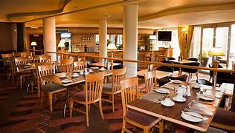

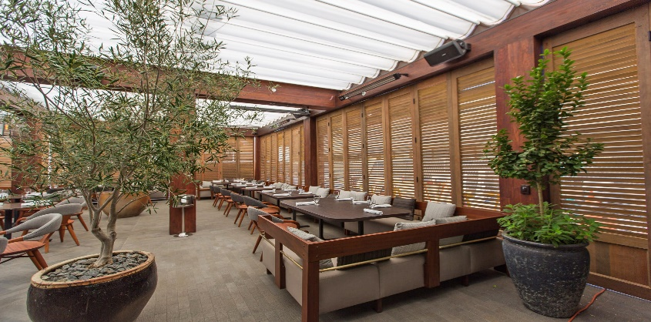

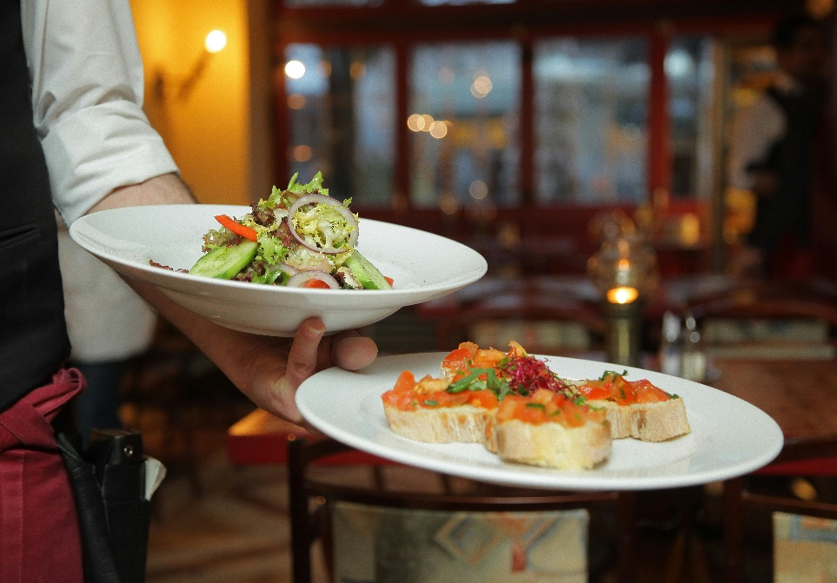

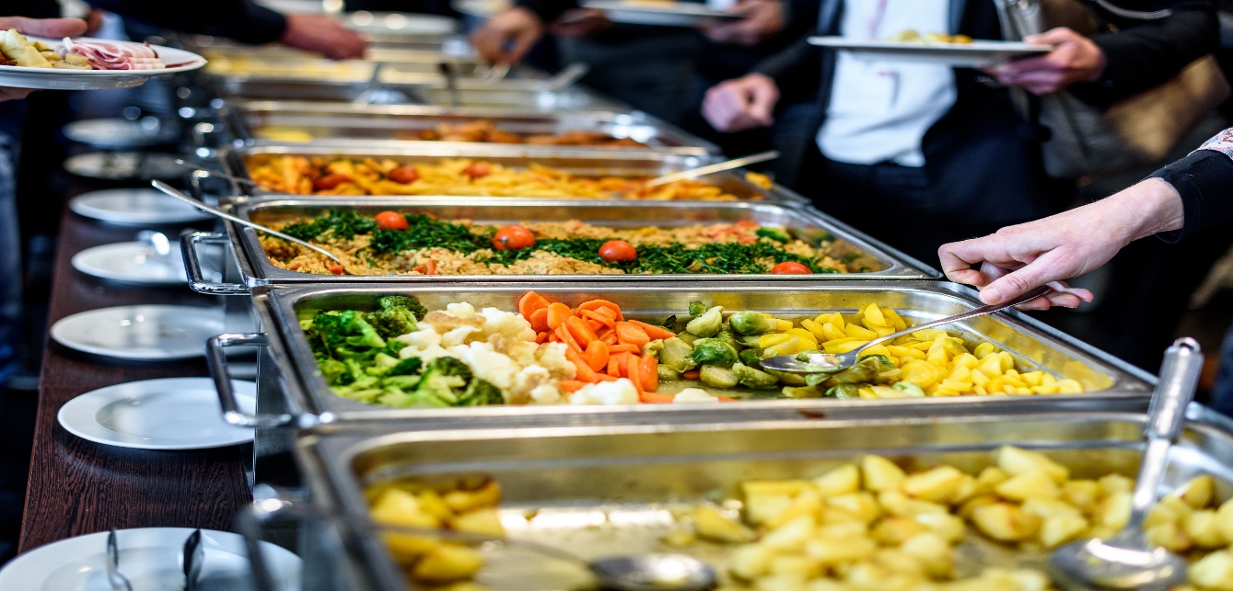

CONCLUSION:

In conclusion, creating a one-page website for a restaurant in WordPress offers a streamlined and effective way to showcase the restaurant's offerings and attract customers. By following the outlined methodology, we've successfully developed a visually appealing, user-friendly, and functional website that reflects the restaurant's brand identity and engages visitors.

Through careful planning, customization, and optimization, we've created distinct sections for About Us, Menu, Specials, and Contact Us, ensuring that users can easily access relevant information. The website is mobile-friendly, responsive, and thoroughly tested to provide a seamless experience across all devices.

By launching this one-page website, the restaurant now has a powerful online presence that enhances its visibility, attracts new customers, and fosters connections with existing patrons. With ongoing maintenance and updates, the website will continue to serve as a valuable tool for promoting the restaurant and driving business growth in the digital age.